Your website is a great opportunity to communicate your offerings with Lexile measures. You can:
- Highlight Lexile measures in your online catalogs by including Lexile measures on the book entries and book descriptions.
- Create search filters that include Lexile measures for your web-based searches.
- Offer an overview of Lexile measures in a “What’s this?” pop-up or as an informational web page.
- Create art demonstrating how you use Lexile measures or add photos showing Lexile measures on your books or showing readers that have found their perfect reading matches in your books with Lexile measures.

Here are templates of different lengths to use as a website pop-up or informational web page.
About Lexile Measures: A “What’s This Pop-up” Website Template (96 words)
Note: Be sure to describe how Lexile measures are used in your product or for your collection of books.
What is a Lexile measure?
[COMPANY NAME] offers Lexile measures on our books to help the millions of learners across the globe with Lexile measures connect with books that are ideal reading matches. Recognized as the world’s most widely used reading metric, Lexile measures are a great way to encourage and monitor reading growth toward learning standards. Lexile measures range from below 0L for learners who are just starting to read and early reading texts [English and/or Spanish] to above 1600L for advanced readers and text. For more information on Lexile measures, visit lexile.global.

About Lexile Measures: A “What’s This Pop-up” Website Template: (260 words)
Note: Be sure to describe how Lexile measures are used in your product or for your collection of books.
What Is a Lexile measure?
[COMPANY NAME] offers Lexile measures on our books to help the millions of learners across the globe with Lexile measures connect with books that are ideal reading matches. There are two Lexile measures: the Lexile learner measure and the Lexile text measure. A Lexile learner measure is obtained when a learner takes a reading comprehension test that is linked to the Lexile scale. Over 35 million learners from across the globe receive Lexile measures from many different popular reading assessments and programs. The learner’s measure represents their reading ability and can be used to monitor progress toward learning standards and to help plan for university and career.
A Lexile text measure represents a text’s difficulty level on the Lexile scale. More than 100 million books, articles and websites have Lexile text measures. When text and learner Lexile measures are used together, they can help learners choose books or other reading material that is at an ideal difficulty to spur reading growth. Lexile measures are expressed as numeric measures followed by an “L” (for example, 850L), and represent a position on the Lexile scale. Lexile measures range from below 0L for beginning readers and text to above 1600L for advanced readers and text.
Today, Lexile measures are recognized as one of the most widely used reading metrics. For more information on Lexile measures, visit lexile.global.

About Lexile Measures: A Web Page Template: (339 words, plus graphic)
Note: Be sure to describe how Lexile measures are used in your product or for your collection of books.
What Is a Lexile measure?
[COMPANY NAME] offers Lexile measures on our books to help the millions of learners across the globe with Lexile measures connect with books that are ideal reading matches. The idea behind the Lexile Framework® for Reading is simple: If we know how well a learner can read and how hard a specific book is to comprehend, we can predict how well that learner will likely understand that book. There are two Lexile measures: the Lexile learner measure and the Lexile text measure.
A learner gets a Lexile learner measure from a reading test or program. For example, if a student receives an 880L on a reading test, their Lexile learner measure is 880L. More than 65 popular reading assessments and programs report Lexile learner measures.
A book or text passage gets a Lexile text measure when it’s analyzed by MetaMetrics®. For example, the first Harry Potter book measures 880L, so its Lexile text measure is 880L.
When the Shoe Fits
You know your shoe size. But imagine how frustrating it would be to try to buy shoes if you couldn’t find out what size they were. The same goes for non-Lexile reading scores. A student scored “286” in reading, for example – what would that mean? How would that student find materials to match a “286”?
That’s what makes the Lexile Framework for Reading different from other reading scales. It comes to life when you match a Lexile reader measure with a Lexile text measure. The Lexile scale is like a thermometer from below 0L for beginner readers to above 2000L. The Lexile measure is shown as a number with an “L” after it – 880L indicates an 880 Lexile measure. When a Lexile text measure matches a Lexile learner measure, this is called a “targeted” reading experience. The learner will likely have some challenge with the text, but not enough to get frustrated. This is the best way to grow as a reader – with text that’s not too hard but not too easy.

Create Art or Use Photos to Illustrate the Value of your Lexile Measured Books
The following is an example of how Houghton Mifflin Harcourt created a poster to illustrate how its Lexile measured books grow with readers. Developing art or using graphics with your website (as well as media, social media and email campaigns) will further amplify your messages about your Lexile measured offerings.
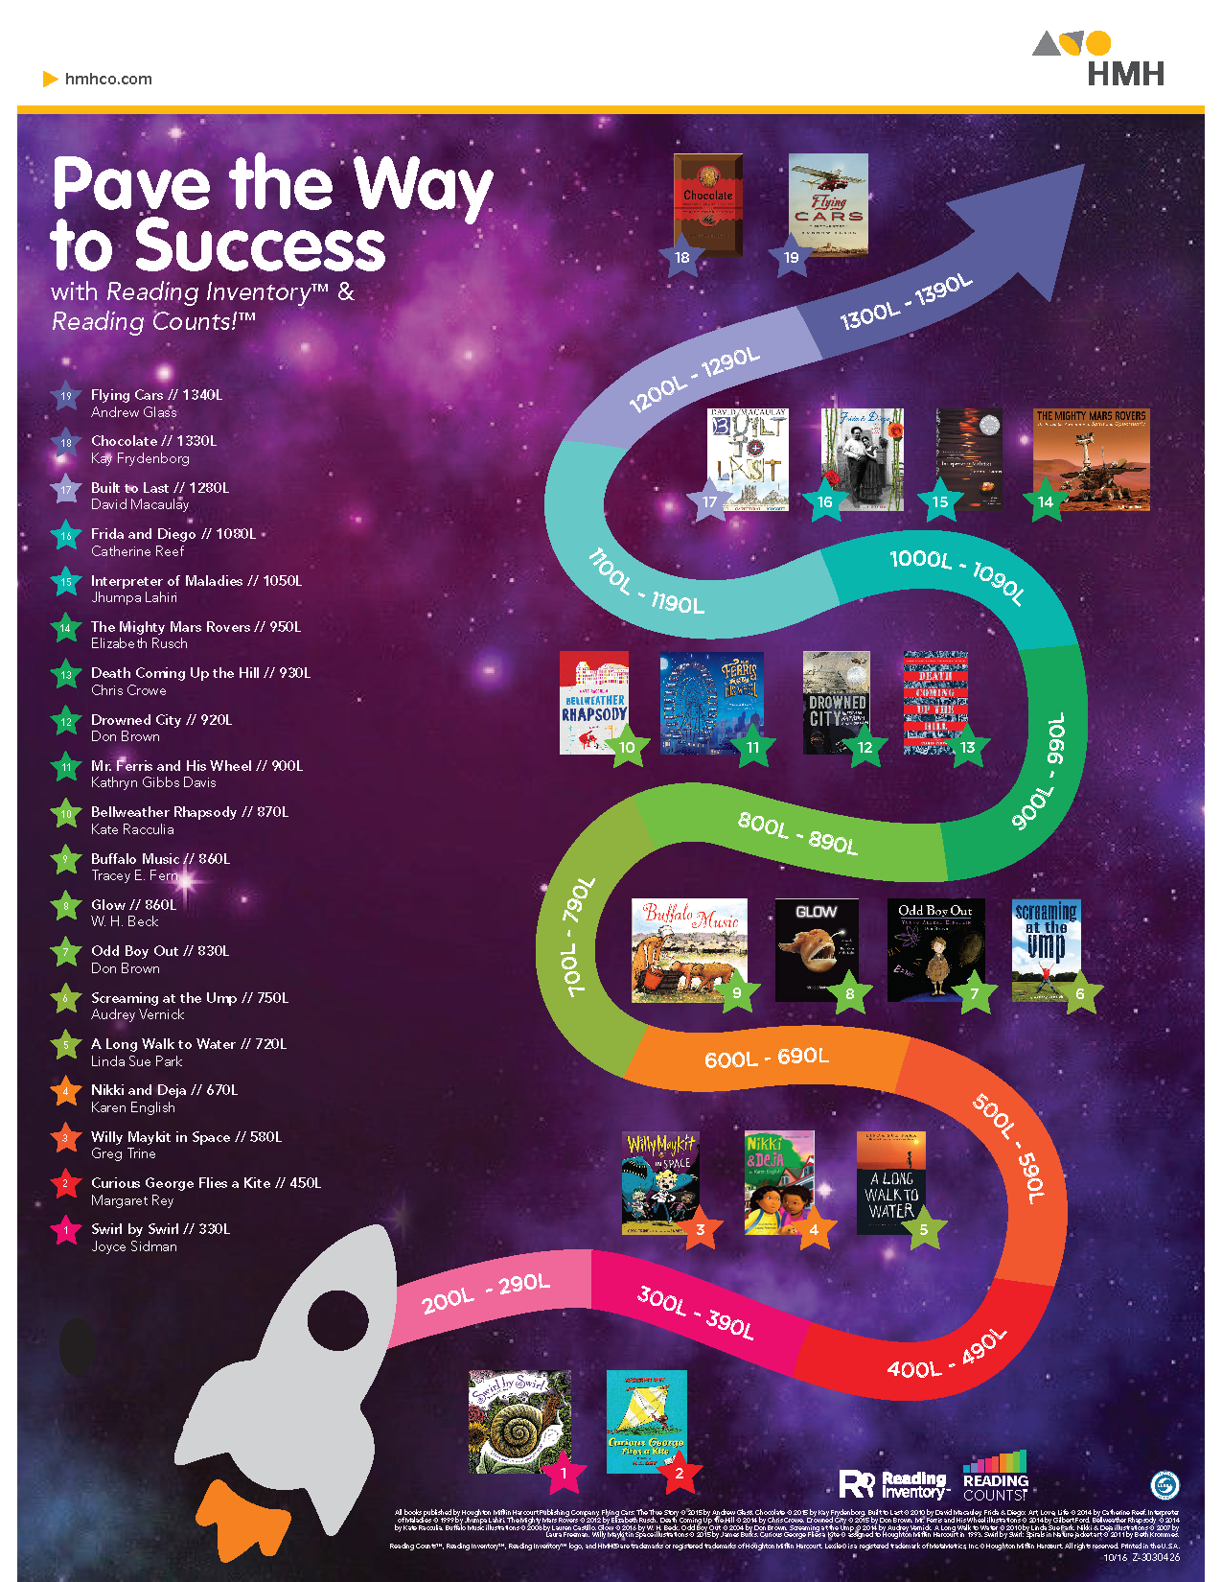

Want to view website examples from our partners?
Visit the See How Others Use the Measures section of the Toolkit at: https://lexile.global/publisher-toolkit/partners/.

